📌 A&I Contract Center Signing/Sealing and Archiving SOP
⚠️⚠️Contract Signing/Sealing application must be submitted after the whole contract approval process is completed.

Step 1 Initiate Contract Signing/Sealing Process (BD)
After the contract is approved, click on "Sign" at the Contract Details page to initiate the Signing/Sealing process
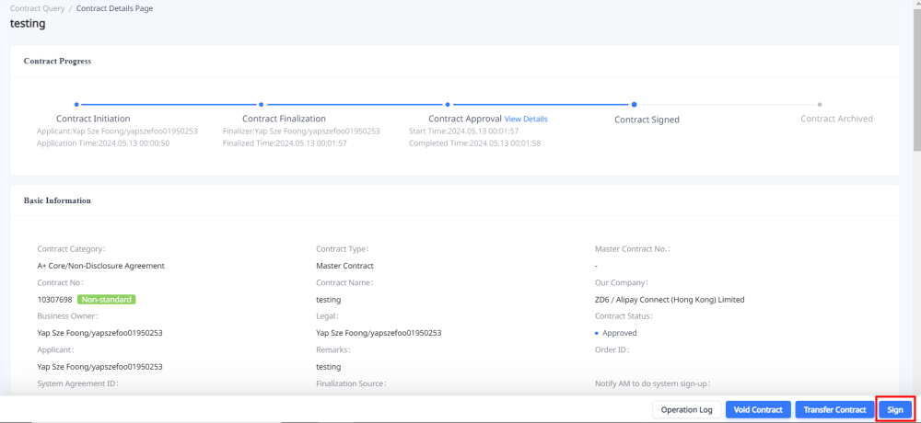

Step 2 Choose the Signing/Sealing method
Note
- Contracts involving A&I mainland China entities (e.g. ZQ2; Z1J, etc.) are only effective after being stamped with a company seal.
- Contracts involving overseas entities (e.g., B15; ZAA; Z15；B31, etc.) requiring signing by the authorized signatory of the related entity to be effective. If any special requirements, please consult the legal PIC of your contract.
- A&I authorized signatories do not accept any contract signing links sent by external companies (counterparty/ merchant/ partner). Do not disclose signatories' name, email address, or personal details to external companies (counterparty/ merchant/ partner), including Alibaba.
- For contracts involving overseas A&I entities (outside mainland China) that require both sealing and sealing, please contact @艾希after the internal signing process is completed for sealing. For physical sealing, please courier the signed hard (physical) copy to the A&I HK office.
- Please do not include authorized signatory details for A&I entities in the contract, as these may change per Corporate Governance requirements. Contracts with signatory information errors will not be signed.
- To verify the authorized signatory for contracts, refer to https://corporation.antgroup-inc.cn/gf/companySearch/publicSearch

1、Signing Process for A&I Overseas Entity (e.g., B15; ZAA; Z15；B31, etc.)

(1) DocuSign Electronic Signature (Docusign) Guideline
Note:
- We only support Docusign, other e-signature platforms are not supported.
- Please do not disclose our signatories'email address, or other information to external companies (counterpaty).
- IMPORTANT !!! -- Authorized signatories of A&I entity do not sign on any e-signing links sent by external companies (counterparty)

a、Docusign (Co-Sign)[Highly Recommended 🌟🌟🌟🌟🌟] --The authorized signatories of all signing parties sign the contract via the Docusign signature link sent by A&I.
- Choose the signing order: Our company signs first OR The counterparty signs first.
- Select "Electronic signature (via Docusign electronic signature")
- Select YES to "Send Docusign envelope to Counterparty".
- Click “Add signatory information” to key in counterparty signatory details. You may enter multiple signatories. (The signatory information added here is the Authorized Signatory of the Counterparty. Please get these information from the counterparty.)
- Enter counterparty Cc. Recipients details if necessary. (The Cc. recipient does not sign on the contract.)
- Set the ”Signing Order” and “Cc. order” for counterparty signatories & Cc. recipient. If none, no specific order is set. Counterparty recipients will receive the Docusign at the same time.
- After confirming on the information entered, click on "Initiate Electronic Signature" (The signing task will not be triggered automatically. The Docusign is sent to the signatories after the operations team checks on the contract to be sent and configures the Docusign signing task).
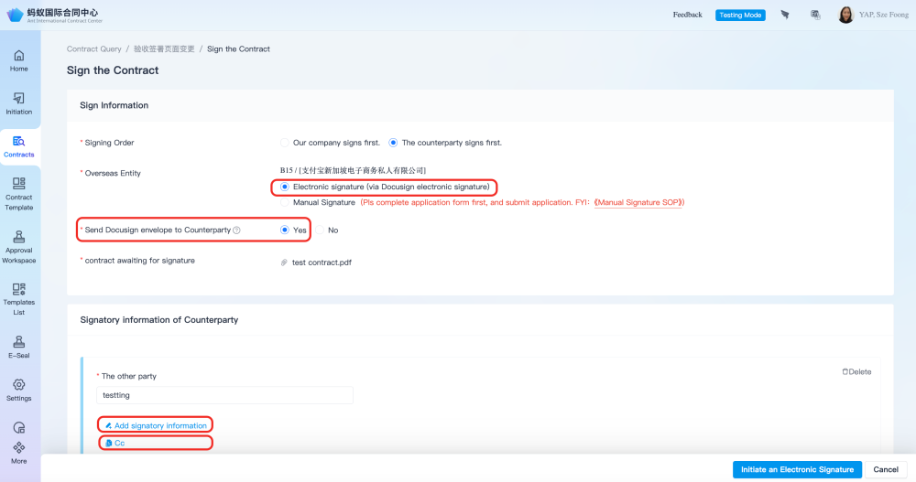
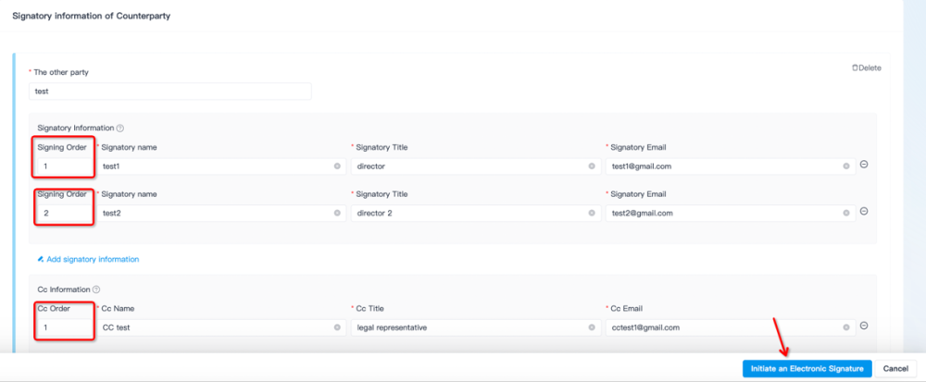

b、Docusign (Not Co-Sign)[Recommended🌟🌟🌟] --A&I Entity signs via our Docusign link, counterparty signs using their own methods
- Choose the signing order: Our company signs first or The counterparty signs first. (If Our Company signs first is selected; download the copy signed via Docusign by our authorized signatory and share it to the counterparty to get their signature. If the counterparty signs first on the contract, please upload the contract signed by the counterparty so that our authorised signatory can countersign on it. )
- Select "Electronic signature (via Docusign electronic signature")
- Select NO to "Send Docusign envelope to Counterparty".
- After the information confirmed, you can click "Initiate Electronic Signature" (The signing task will not be triggered automatically. The Docusign is sent to our authorized signature after the operations team checks on the contract to be sent and configures the Docusign signing task ).
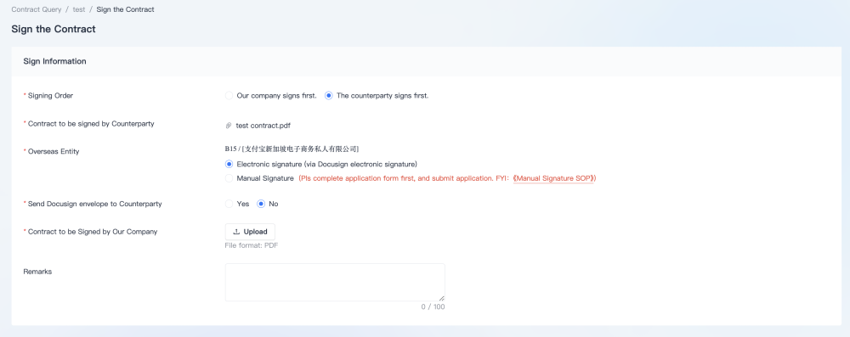

（2）Wet-Ink【Not Recommended】--Hardcopy signing offline, both parties must sign on the same original hardcopy (May require cross-border courier).
- Choose the signing order: Our company signs first or The counterparty signs first.（If our company signs first, please share the hard copy signed by A&I's authorized signatory with the counterparty for their signature; if the counterparty signs first, please share the hardcopy signed by them with our authorized signatory's secretary to arrange for physical signing）
- Choose："Manual Signature"
- Click "Enter" to fill in the Wet-Ink Application Form. Please return to the same signing setup page at the contract center after submitting theses form.
- Tick the "Completed" box
- After confirming the entered details , click on "Submit"
⚠️Note：For wet-ink signing, all parties must sign on the same original document. Wet-ink signatures on scanned copies are not valid. If signing on the same hardcopy cannot be carried out, choose the Docusign signing method instead.
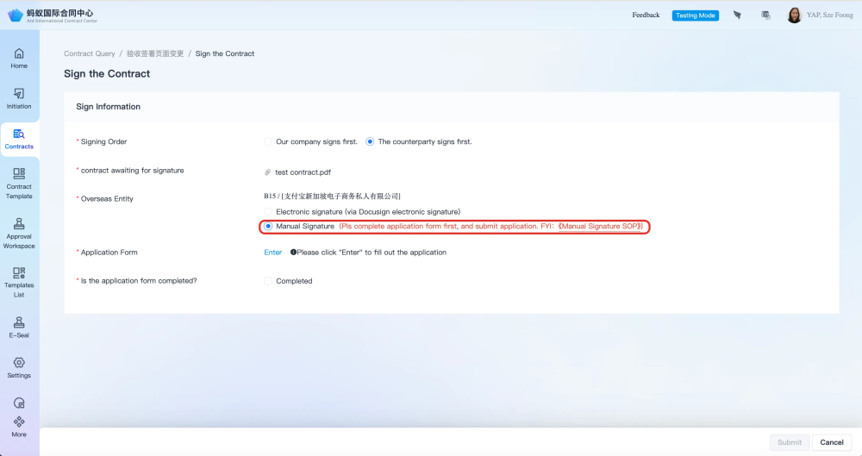
Contact the secretary of the authorized signatories listed below to arrange for wet-ink signing.
Authorized Signatories | Secretary/Admin Support | Office | Address
Wang Yi 王軼 | @Cheung Siu Fong Farina | HK Office | As advised by the secretary
Xu Xian（邂智） | @Koh Qian Yi | SG Office | As advised by the secretary
Leiming Chen | @Cheung Siu Fong Farina | HK Office | As advised by the secretary
Zhou Yi (Bamboo Official) | Mimi | SG Office | As advised by the secretary
Signing of contract for CFM - BANK account opening : Please contract @鲥鱼to confirm on the Authorized Signatory.
To verify on the authorized signatory for the specific entity, refer to ：https://corporation.antgroup-inc.cn/gf/company/publicSearch
Example:
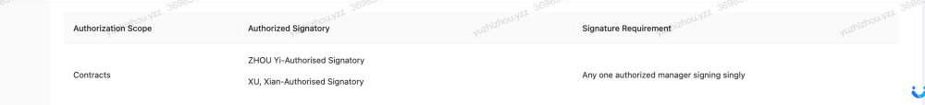

2、Seal application process for contracts involving A&I mainland China entities (ZQ2; Z1J, etc.)

（1）Physical Seal-- Requires physical submission of original hardcopy contract at Ant A Space (Hangzhou) to complete Physical Sealing on contract
- Choose the signing order: Our company signs first or The counterparty signs first. (If our company signs first, please share the copy affixed with our company's seal after the sealing process is completed with the counterparty in order to get their signature; if the counterparty signs first on the contract, please upload the copy already signed by the counterparty so that we can affix the seal on it the signed copy.)
- Choose："Physical Seal"
- Confirm Seal Method (If we sign first, you may choose to either sent the physical copy to A Space for sealing or have the Sealing Support PIC print it a copy for sealing at A Space. If the Counterparty signs first on the contract, the hardcopy with the Counterparty's signature must be sent to the A Space for sealing.)
- Enter the number of contract copies that need to be sealed
- After confirming the entered details, click on "Start physical Seal Affixing"
Contract submission address: Rooms 501 & 502, Building 8, Ant Financial A Space, Hangzhou ,Zhejiang Province, China [Physical seal DingTalk Support Group No.: 40970000545]
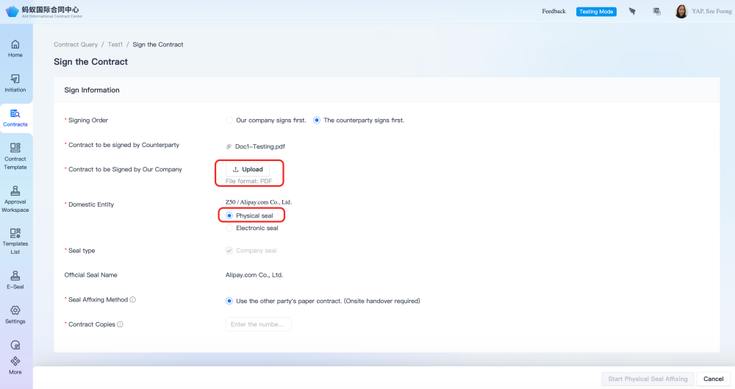

（2）Electronic seal--Online submission with e-sealing
- Choose the signing order: The counterparty signs first. （Electronic seal, only available if the counterparty signs first on the contract.）
- Choose："Electronic seal"
- Choose Seal Position
- After confirming on the entered information, click on ""Start electronic Seal Affixing""（Kindly wait for the e-sealing operations team to complete file version checks and configure e-sealing after intiating.）
⚠️Note: Electronic seals are permitted only for overseas counterparties. Domestic entities must use an e-seal with a valid CA certificate if required."
How to verify CA Certificate：https://contract.antgroup-inc.cn/homePage/CaVerification
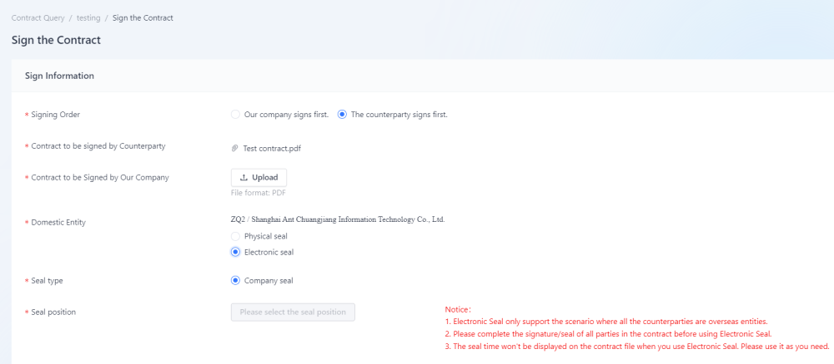
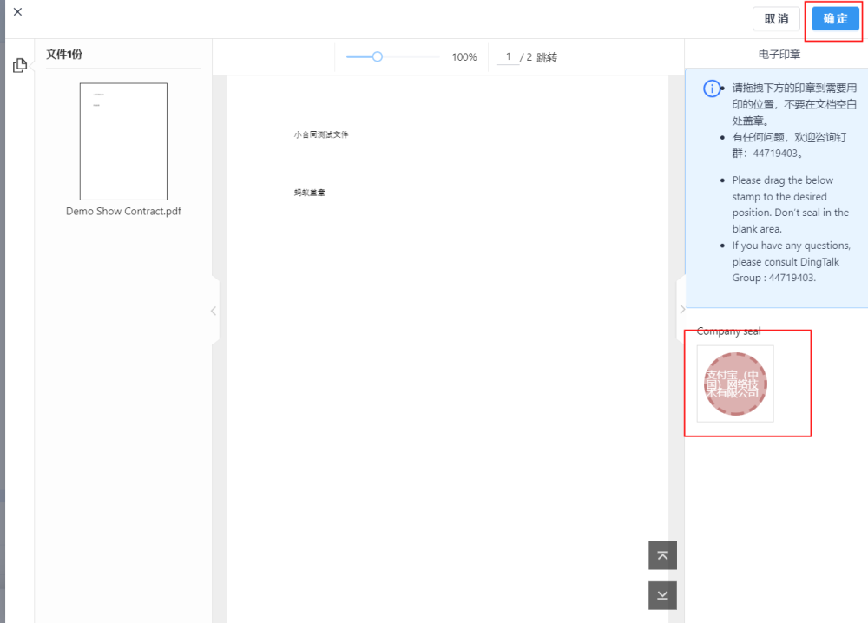

3、Multiple-Entity Signing/Sealing Process

（1）All A&I entities are overseas entities
The signing process and supported signing methods are the same for contracts involving single A&I overseas entities.

（2）All A&I entities are domestic entities
Only supports physical sealing

（3）A&I entities involves both overseas and domestic (multiple cross-border entities).
Note: If the contracting party includes an A&I domestic entity, this domestic entity must be included in the "our company" field when initiating the contract; otherwise, sealing of the contract which is necessary for A&I domestic entities cannot be done
Combined signing and sealing for both domestic and foreign entities is supported. However, signing for the overseas entity must be completed first. Sealing for the domestic entity can only be carried out after signing is completed.

Step 3 Tracking Signing/Sealing Progress

1、Docusign - Overseas entities

（1）Application for contract signing has been initiated. Please wait for the signing task to be configured.
Status Definition: This signing task is pending version verification and setup by the Operations team for the Docusign to be sent to signatories. Please await further signing status updates. If any contract version issues found that impact signing, Operations will contact the relevant business team.
(Due to the high volume, signing tasks will be arranged based on submission order , first come-first served basis.)
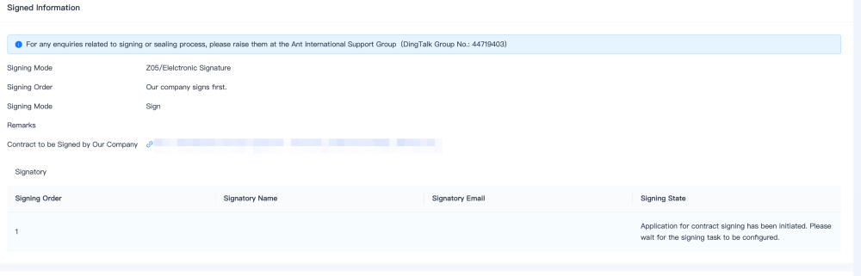

（2）Signing
Status Definition: The Docusign has been sent to signatories and pending signatories' signature. Please take note that there is a specific signing order for each signatory.
If you wish to contact the signatories directly to expedite the signing process, please share the [Contract No.] with the signatories so that they can then search for the Docusign signing link in their email inbox with the contract No. (You can do so for both internal and external (counterparty) signatories, but please take note of the selected signing order as the signatory will only receive the Docusign signing link in their email inbox according to the signing order setup.)
(🚨🚨🚨Do not send the contract link to the signatories!!! The contract link is not the signing link, and signatories do not have the system permission to access it.)
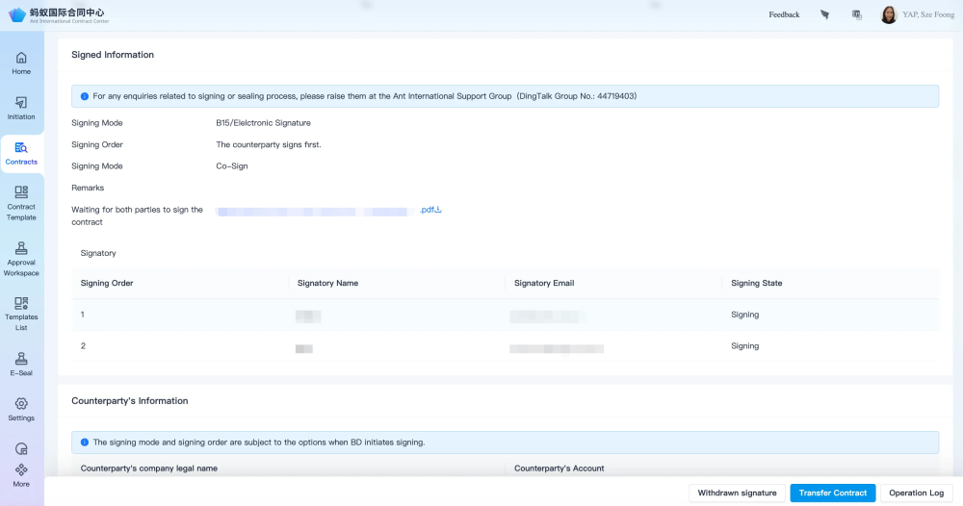

（3）Signed
Status Definition：Signing has been completed, the signed contract file can be downloaded at the contract details page.

a、Docusign (Not Co-Sign)（Our entity signs first）
Please download the contract that has been signed by our signatories and share it with the counterparty for their signature.
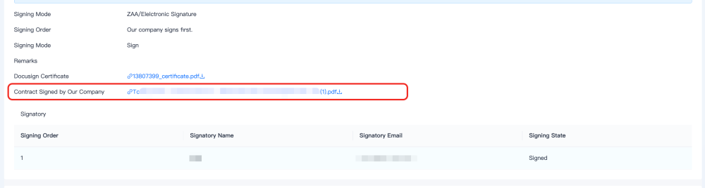

b、Docusign-Co-sign/Docusign (Not Co-Sign)（Counterparty sign first）
Please download the contract that has been signed by both(all) parties.
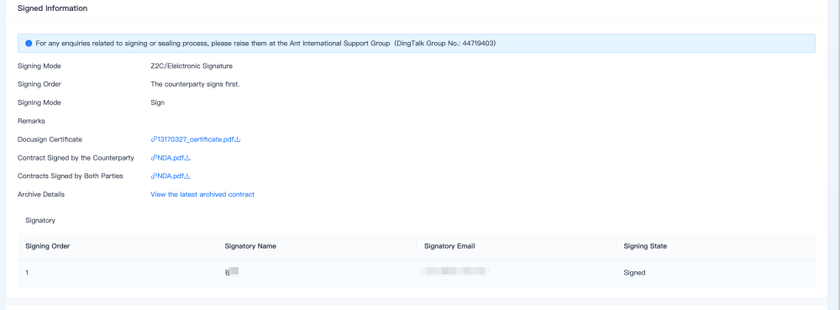

2、Wet-Ink---Overseas Entities
Initiated
Signing
Finished
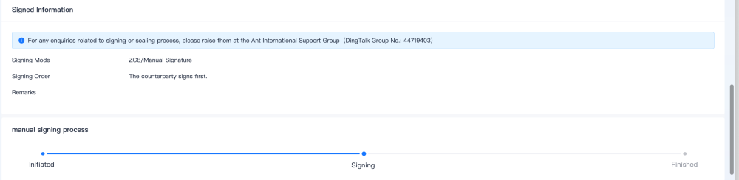

3、Physical Seal-Domestic Entities
- Receive：waiting for contract file to be sent to A Space
- Scan：Scanning of contract file；
- Compare：File Version Check；
- Affix the Physical Seal：Physical sealing of contract is completed.
Note：If you choose to have the contract printed by the Sealing PIC for sealing, the physical sealing progress will be atu-updated with no further action needed. Otherwise, you will need to send the contract to A Space to proceed to the next steps. If any questions，please join the Ding Group 【40970000545】
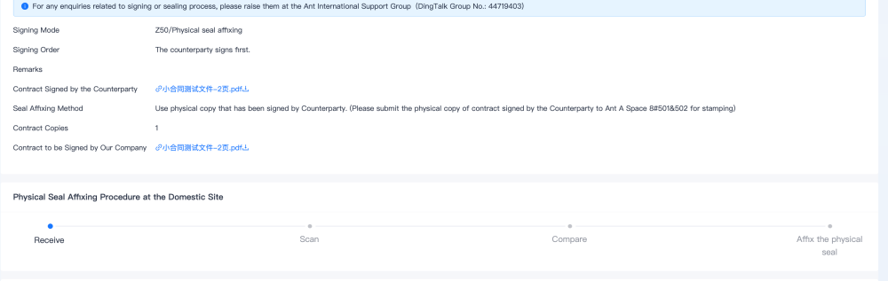

4、Electronic seal--Domestic Entities
- Intiated;
- Reviewing;
- Affixing Electronic seal;
- Finished.
Note: There is a queue for this process. To expedite it, please contact @喻备
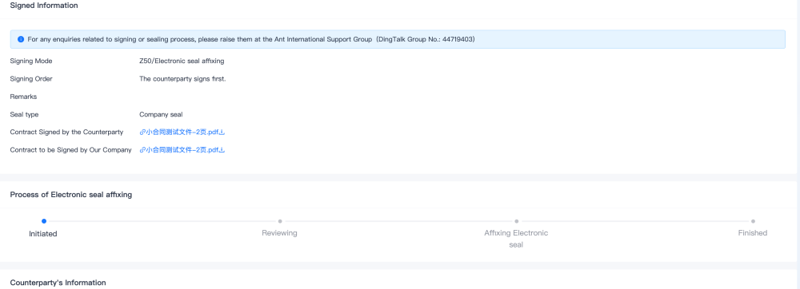

Step 4 Archive Contract

1、Overseas Entity

（1）Docusign（Co-Sign）
Automatically archived. No further action needed.

（2）Docusign（Not Co-Sign）-Counterparty Sign first
AAutomatically archived. No further action needed.

（3）Docusign（Not Co-Sign）-Our Entity Sign first
After counterparty signs on the contract containing A&I's signature, please upload the version signed by both (all) parties to the Contract Detail page.(Please input the counterparty's signing date)
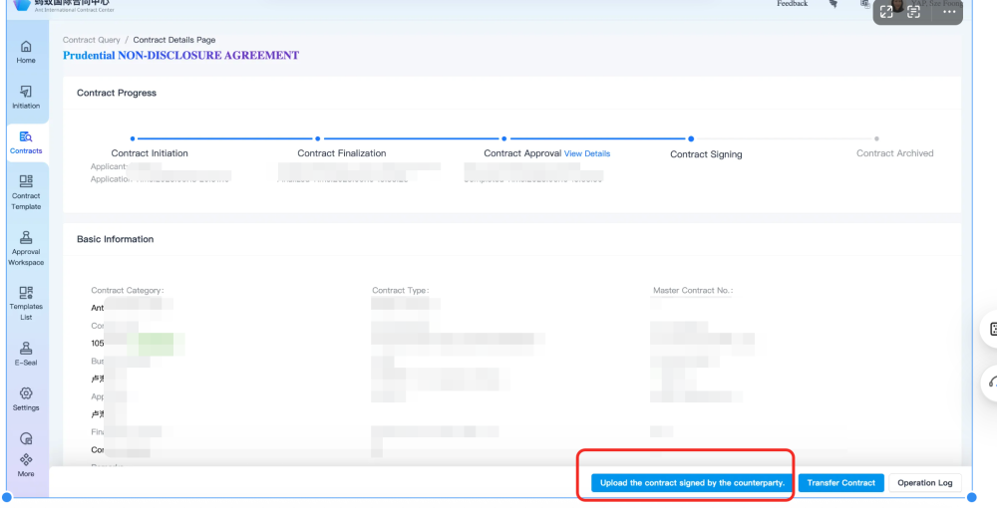

（4）Wet-Ink
After all parties have signed, please upload the copy that is signed by all parties to the Contract Details page.
Please mail the original hard copy to the address below for archive：
English address:Building E, Huanglong International Center, No. 77 Xueyuan Road, Hangzhou, China
Chinese address: No. 77 Xueyuan Road, Xihu District, Hangzhou City, Zhejiang Province, Huanglong International Building E, Small Post Office
Post code/Post code: 310012
number/Contact information: 17857687452
name: Qian Lu/Qian Lu
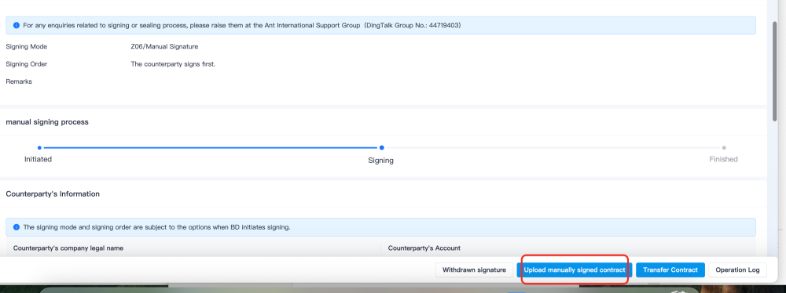

2、Domestic Entity

（1）Electronic seal
Automatically archived. No further action needed.

（2）Physical-Counterparty sign first
Automatic archived. No further action needed.

（3）Physical-Our entity sign first
After counterparty has signed on the copy with A&I's signature, please send the physical copy signed by both parties to Ant A Space 8#501&502 for archiving.

Support Team
Ant International Contract Center Support Group DingTalk ID ：44719403
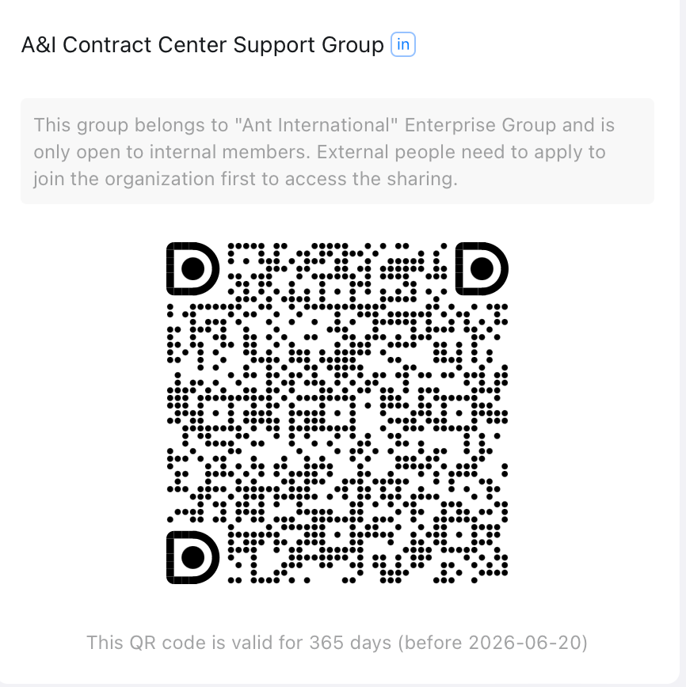
Docusign Operation：@艾希
Wet Ink Process Operation：@鹿漆
A&I Contract Center Process Support：@天宜@兔丁PD ：@江鎏Tech：@羽书@苍瑜

